**Muhammad Uzair**

**529583**

**Assignment 3 Documentation**

**Overview**

**This assignment focuses on developing a comprehensive hospital management system with three main packages, each addressing specific functionalities to enhance the hospital's operational efficiency and user experience. Below is an explanation of the packages and their respective functionalities:**

**1. EmergencyAlertSystem**

**This package is designed to handle emergency conditions within the hospital system. It includes classes and methods to:**

* **Monitor patients' vital signs and trigger alerts when they cross predefined thresholds.**
* **Send emergency emails to notify relevant personnel about critical conditions.**
* **Allow manual triggering of emergency alerts by authorized users.**

**2. ChatAndVideoConsultation**

**This package facilitates interaction between patients and doctors through:**

* **A chat system that uses file handling to store chat histories permanently for future reference.**
* **Additional functionalities to enhance the chat experience.**
* **A video consultation feature that generates Zoom meeting links, which can be accessed via Google for virtual consultations.**

**3. NotificationsAndReminders**

**This package ensures that patients and doctors receive timely reminders and notifications about:**

* **Upcoming appointments.**
* **Important updates via email and SMS.**

**Test Results**

**The assignment also includes test results for the Hospital System, demonstrating the functionality and reliability of the implemented features.**

**List of Features**

1. **Menu Section:**

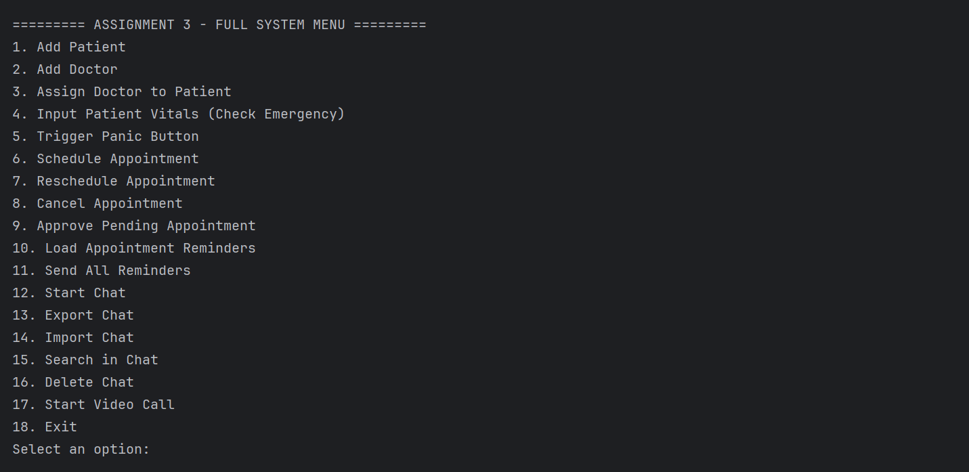

1. **Add Patient**

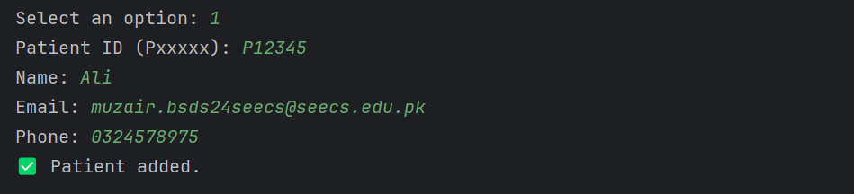

1. **Add Doctor**

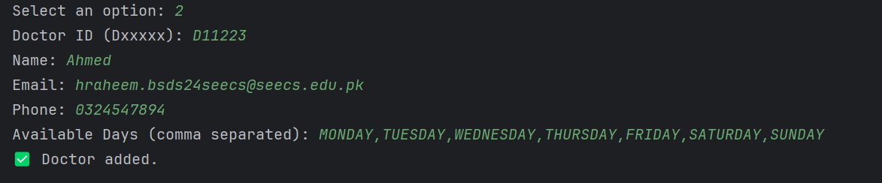

1. **Assign Doctor to Patient**

1. **Input Patient Vitals (Check Emergency)**

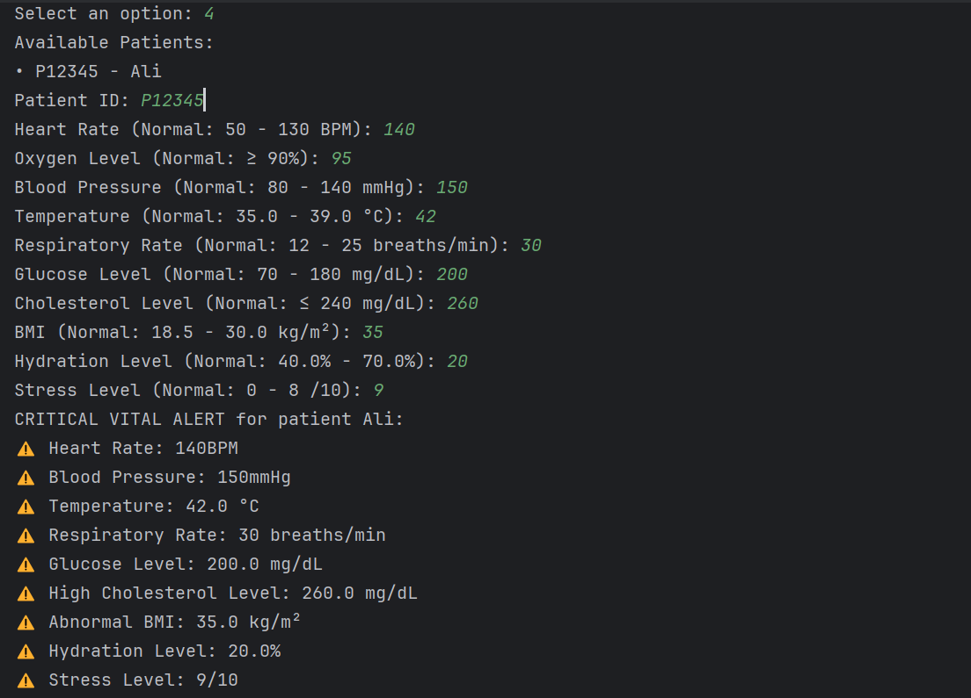

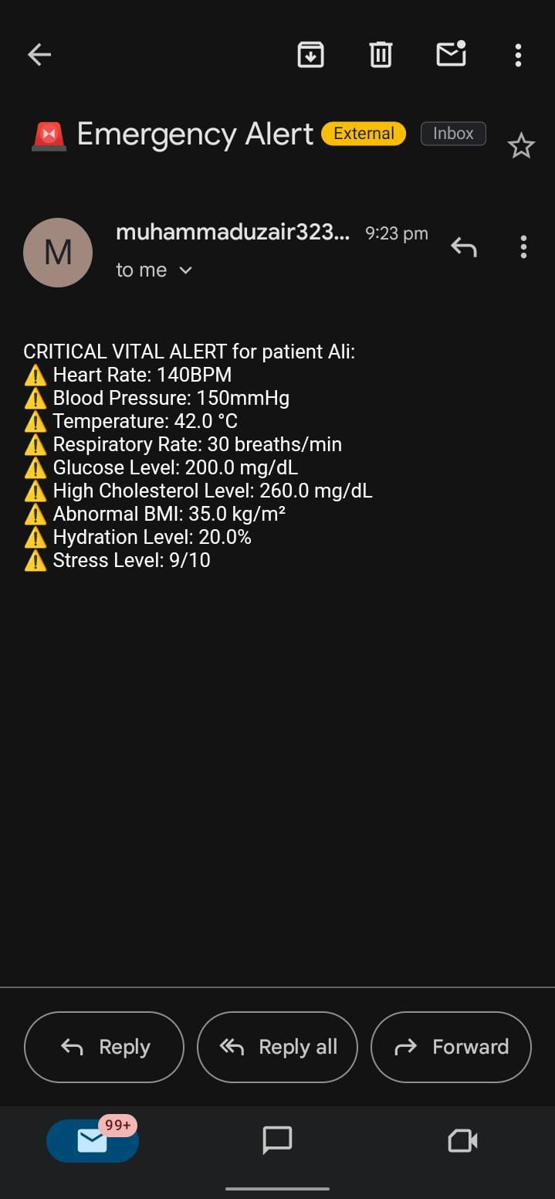

1. **Trigger Panic Button**

1. **Schedule Appointment**

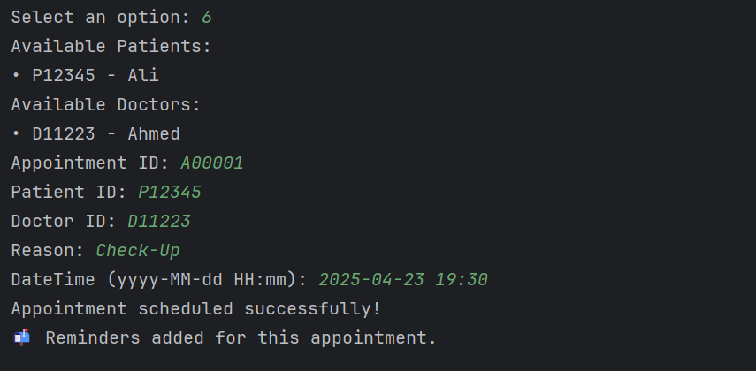

1. **Reschedule Appointment**

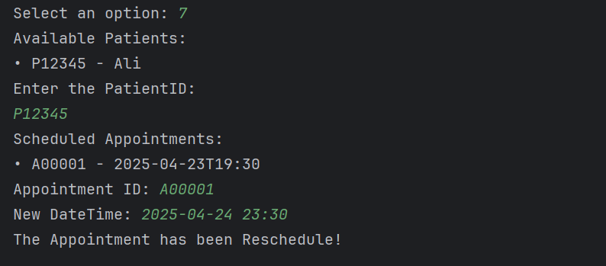

1. **Cancel Appointment**

1. **Approve Pending Appointment**

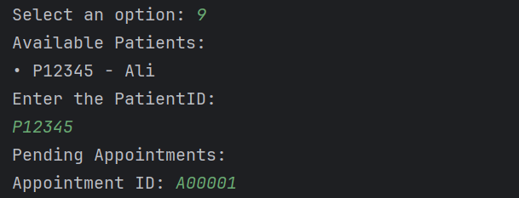

1. **Load Appointment Reminders**
2. **Send All Reminders**

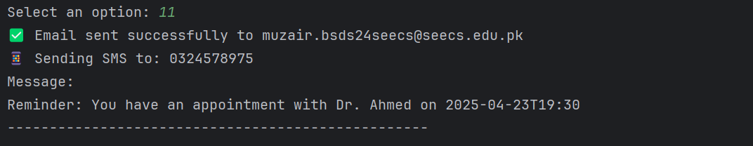

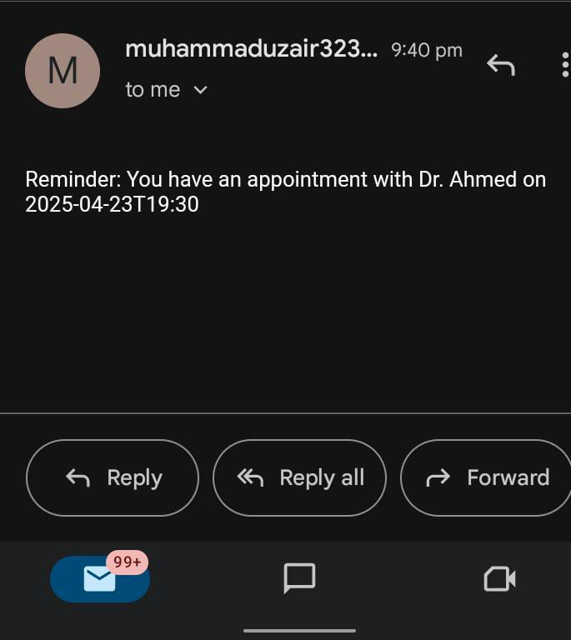

1. **Start Chat**

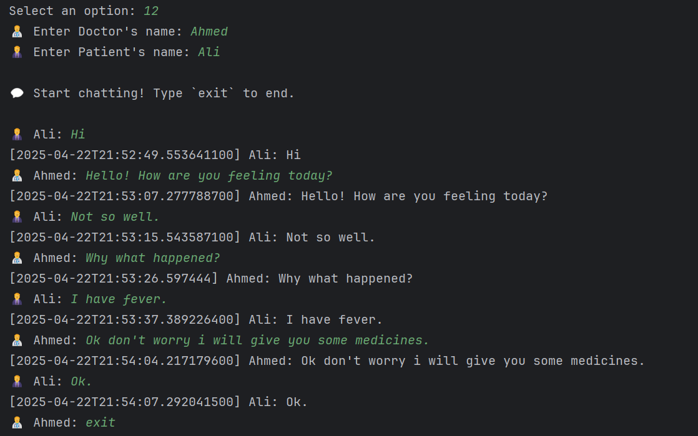

1. **Export Chat**

1. **Import Chat**

1. **Search in Chat**

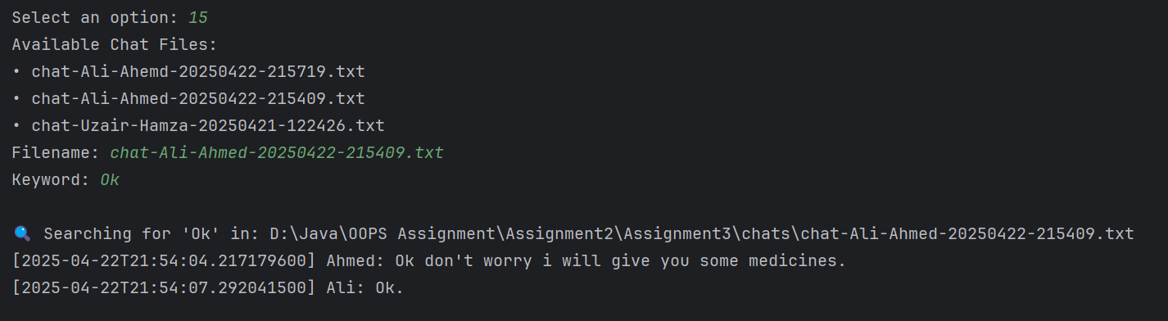

1. **Delete Chat**

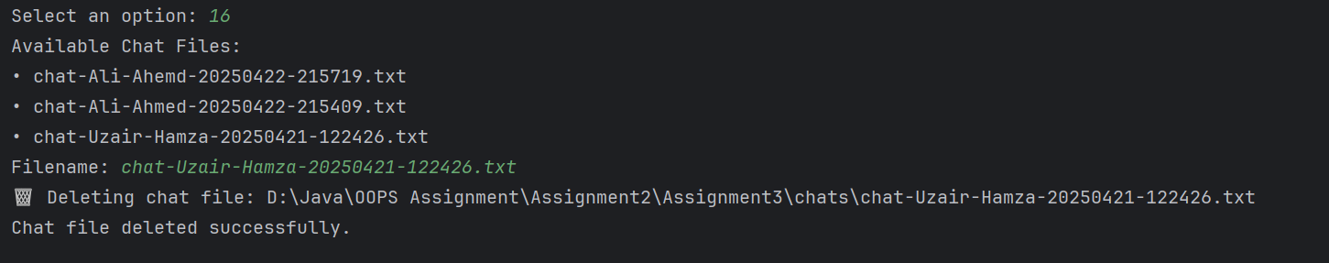

1. **Start Video Call**

GitHub Repo.